The Private Eye
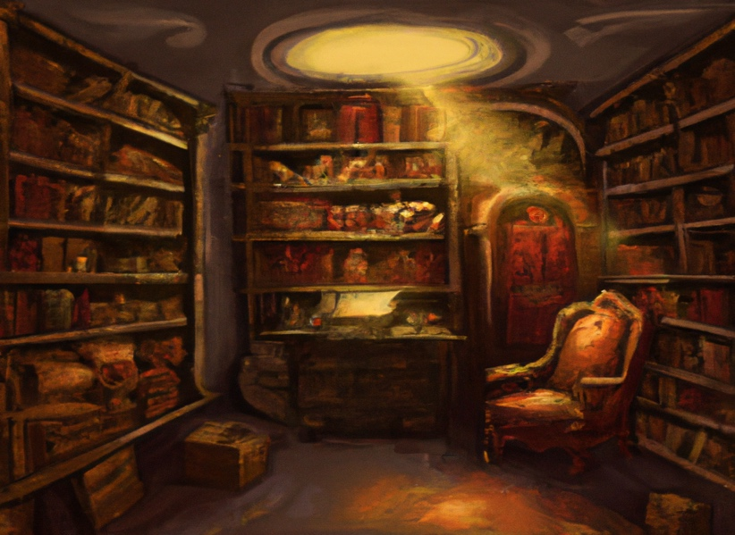
“A detective’s library in the style of an oil painting,” generated by DALL·E 2

Problem to Solve
CS50’s duck debugger has disappeared once more and you desperately need a detective. You’ve heard stories of one who lives uptown, always secretive in their work, never seen but when they want to be. Unsurprisingly, they’ve proven to be quite elusive to you. But here you are, in their study, after picking up their address from a certain mail clerk.
On their mahogany desk, fresh white paper glints. Inscribed is the following table:

14 | 98 | 4
114 | 3 | 5
618 | 72 | 9
630 | 7 | 3
932 | 12 | 5
2230 | 50 | 7
2346 | 44 | 10
3041 | 14 | 5
And tucked underneath, a worn book, The Adventures of Sherlock Holmes.

Distribution Code
For this problem, you’ll need to download private.db and private.sql.
Download the distribution code

Background
Given the paper’s proximity to The Adventures of Sherlock Holmes, what’s written on it seems to be some variation of a book cipher. You know that in one version of a book cipher, the cipher’s creator gives you a list of “triplets” (i.e., a set of three numbers). Each triplet is structured as follows:
- The first number in the triplet is the sentence number referenced by the encoder.
- The second number in the triplet is the character number, within that sentence, at which the message begins.
- The third number in the triplet is the message length in characters (i.e., how many characters to read from the first, including spaces and punctuation).
For instance, consider the triplet 2, 1, 8 in light of the following sentences:
Quite so! You have not observed. And yet you have seen.
2 refers to the 2nd sentence, “You have not observed.” 1 refers to the 1st character in that sentence, “Y.” And 8 refers to the length of the message from that first character. Starting from the 1st character of the 2nd sentence, reading 8 characters (including spaces!) gives you:
You have
You can imagine, now, stringing together multiple tuples to encode a longer message. Perhaps that’s exactly what the detective has done!

Schema
Within private.db, you’ll find a table, sentences. The sentences table contains all sentences in The Adventures of Sherlock Holmes. In particular, it contains the following columns:
- id, which is the ID of the sentence
- sentence, which is the sentence itself

Specification
Your task at hand is to decode the cipher left for you by the detective. How you do so is up to you, but you should ensure that—at the end of your process—you have a view structured as follows:
- The view should be named message
- The view should have a single column, phrase
- When the following SQL query is executed on private.db, your view should return a single column in which each row is one phrase in the message.
- SELECT "phrase" FROM "message";
In private.sql, you should write all SQL statements required to replicate your creation of the view. That is:
- If creating the view requires creating a separate table and inserting data into it, you should ensure that private.sqlcontains the statements to create that table and insert that data. (Don’t be afraid to add tables and add data as you wish!)
- private.sql, when run a fresh instance of private.db, should be able to fully reconstruct your view.

Advice
Turns out that SQLite handily comes with a function that implements the very functionality of the book cipher: substr. The function substr takes three inputs (“arguments”):
- A string (i.e., text) from which to take a substring (i.e., a subset of the string’s characters)
- The starting character of the substring, identified by its number (the first character is 1)
- The length of the substring

For instance, suppose you have a table called sentences which includes the following:
id
1
sentence
Quite so!
id
2
sentence
You have not observed.
id
3
sentence
And yet you have seen.
Should you run the following SQL query…
SELECT substr("sentence", 1, 2)
FROM "sentences";
you would receive the following results:
substr(“sentence”, 1, 2)
Qu
substr(“sentence”, 1, 2)
Yo
substr(“sentence”, 1, 2)
An
Keep in mind that the other arguments to substr can be entire columns themselves, too!

